Sequence Diagram: User Data Management
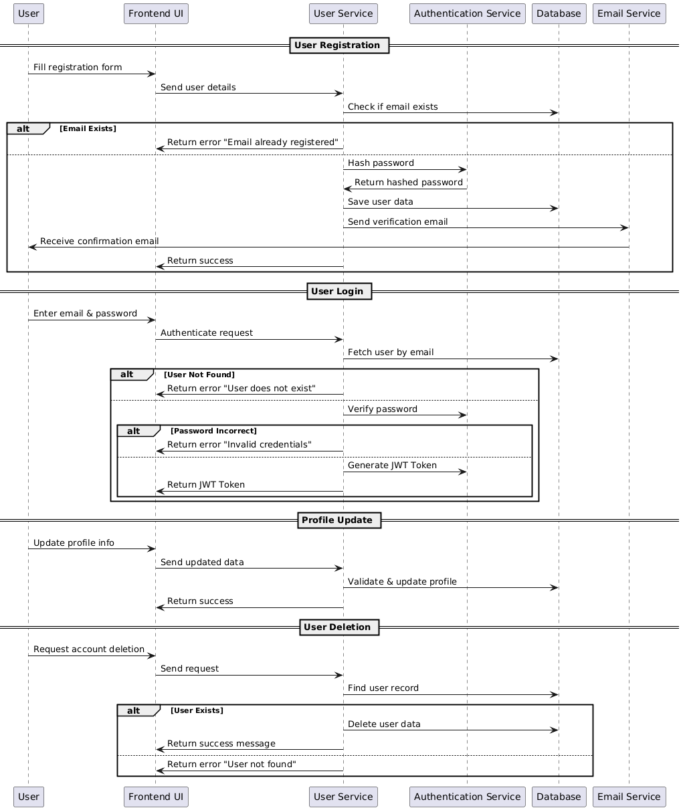

Database
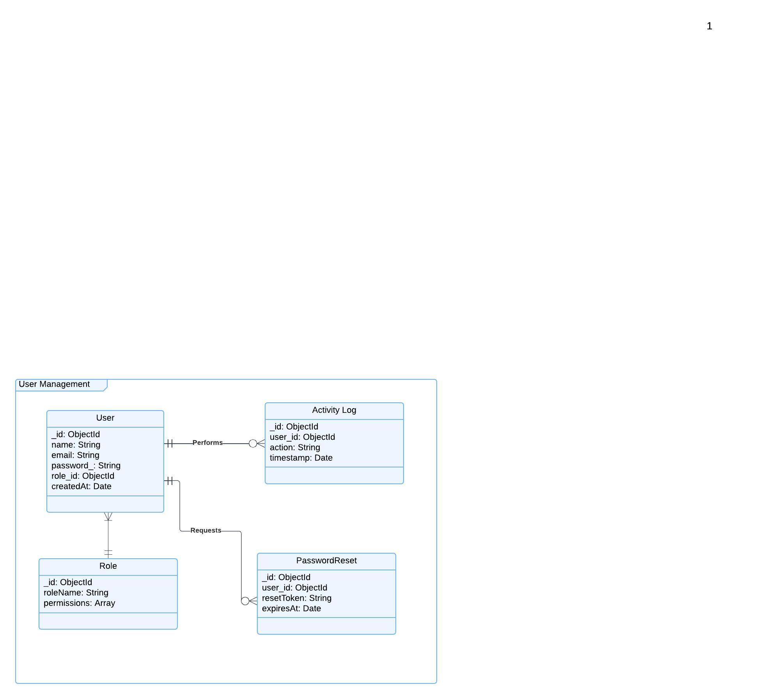

Functional Requirements (FRs)
User Registration
- FR1: The system shall allow users to register with a valid email and password.
- FR2: The backend API shall validate the provided registration details before creating a user account.
- FR3: The backend API shall return an error response if the email is already registered.
- FR4: The frontend shall display appropriate success or error messages after registration.
User Login
- FR5: The system shall allow users to log in using their registered email and password.
- FR6: The backend API shall validate user credentials before granting access.
- FR7: The frontend shall display an error message if login credentials are incorrect.
Profile Management
- FR8: The system shall allow users to update their profile details (name, email, contact, etc.).
- FR9: The backend API shall validate the provided data before updating the profile.
- FR10: The system shall ensure only authorized users can modify their profile details.
Password Management
- FR11: The system shall allow users to reset their password via email verification.
- FR12: The frontend shall display appropriate messages for successful and failed password reset attempts.
User Deletion
- FR13: The system shall allow users to request account deletion.
Role-Based Access Control (RBAC)
- FR14: The system shall assign roles (admin, user) to each user account.
- FR15: Admin users shall have permission to manage other user accounts.
Logging & Monitoring
- FR16: The system shall log user actions such as login, profile updates, and password changes.
- FR17: Admin users shall have access to user activity logs for security monitoring.

Non-Functional Requirements (NFRs)
Performance & Reliability
- NFR1: The system shall process user registration and login requests within 2 seconds.
- NFR2: The system shall handle 1,000+ concurrent user requests without performance degradation.
Security
- NFR3: The system shall prevent unauthorized access by enforcing role-based access control (RBAC).
Usability
- NFR4: The user interface shall provide clear and user-friendly error messages.
- NFR5: The profile management and login pages shall be responsive and work on both desktop and mobile devices.

